___________________________________________________
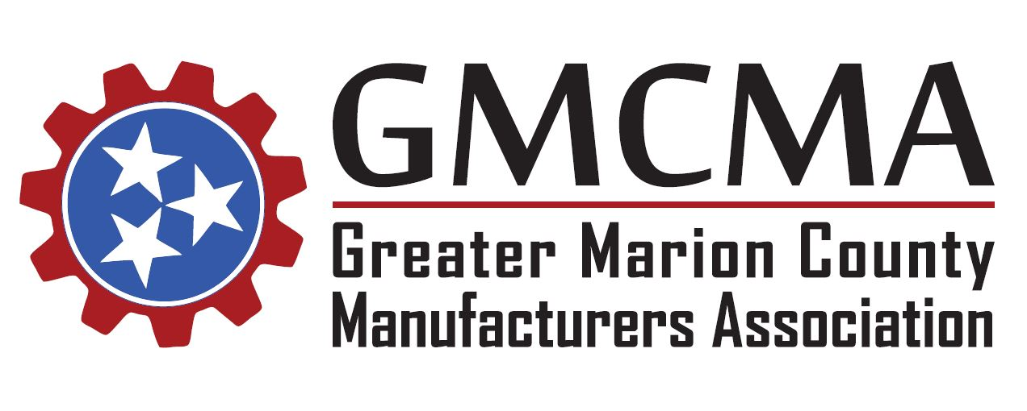

Thursday, February 28th, 2019
Meeting Agenda
- Welcome and new introductions

- Previous meeting minute review

- Announcements

- “Round Table Open Discussion - Retention”
- New Employee Orientation
Do you have a structured NEO program?
- Employee Engagement
Do you have a structured communication process? Daily start up meetings, monthly or quarterly communication meetings?
- Recognition
How do you show respect and appreciation? Do you have a service award or recognition program? Appreciation events?
Please come prepared to discuss a Best Practice with the group.
Adjourn

Remaining 2019 Meeting Dates and Tentative Topics (TBD):
March 28 July 25
April 25 August 29
May 30 September 26
June 27 October 31

