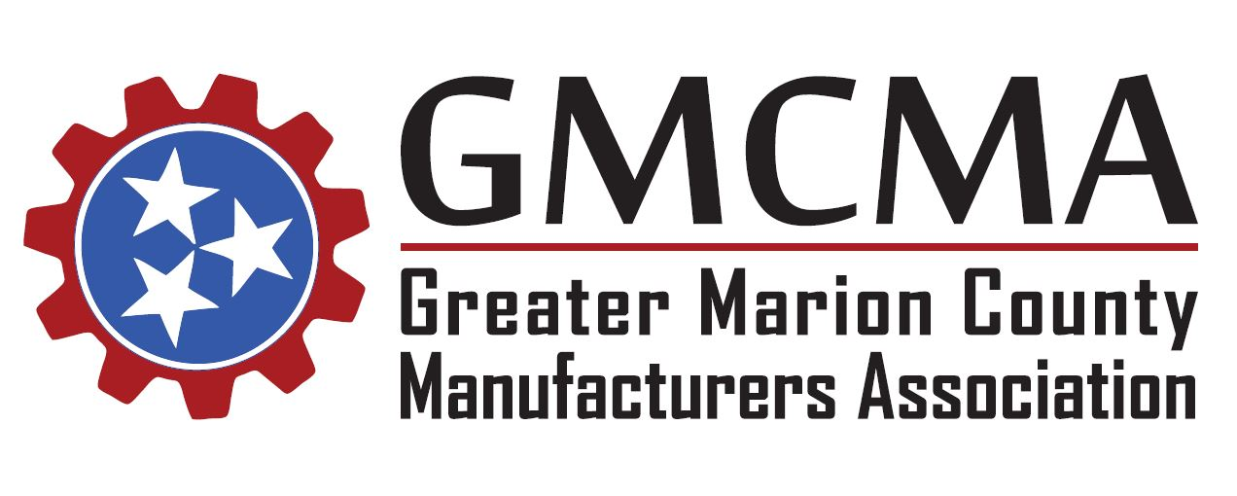

Thursday, July 25, 2019
Meeting Minutes
The Greater Marion County Manufacturers Association met today at 11:30 am CST at Western Sizzlin in Jasper.
- Meeting was called to order by Co-Chair Duane Johnson
  - Stated no new introductions from participants
  - Discussed previous meeting minutes found on the GMCMA website
  - Introduced the guest speaker: Jeff Francis with Bureau of Workers’ Compensation

- Speaker – Jeff Francis, Assistant Administrator, Bureau of Workers’ Compensation
  - Gave a mini introduction of himself and what he does and doesn’t do within the scope of his role
  - Talked on things to improve your workplace culture & worker’s compensation
  - Went over an in-depth PowerPoint on benefits of Workers’ Compensation per state guidelines
  - During presentation handed out various forms to post on site and also updated format of form to post for Workers’ Comp awareness in our own facilities
  - Informed the group about Ombudsman, which is a help-desk tool for Workers’ Comp. Also gave their phone number if needed: 1-800-332-2667
  - Explained that each claim has an insurance adjustor and told the group that the adjustor annual training will be August 20, 2019 – 21st
  - Gave out his personal contact information:
    - Jeff.francis@tn.gov
    - Phone: 615-253-6269
  - He did state he would email out the PowerPoint for the good of the group

- Meeting adjourned by Co-Chair

