___________________________________________________
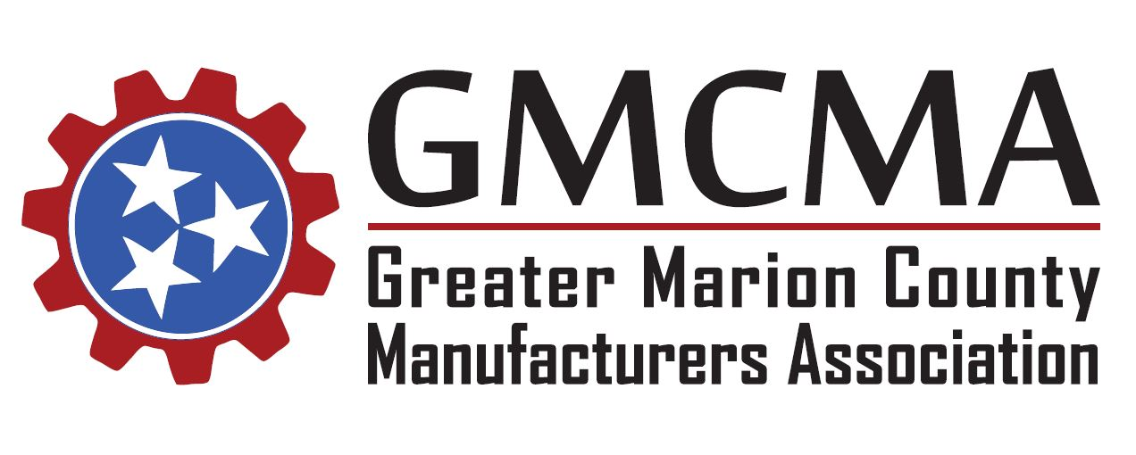

Thursday, July 26, 2018
Meeting Minutes
The Greater Marion County Manufacturers Association met today at 11:30 am CST at Western Sizzlin in Jasper.
Those in attendance included: Amanda Groves (Lodge Manufacturing), Sam Touchstone (Lodge Manufacturing), Andrea Kiefer (Ply Gem), Brenda Chambee (Ply Gem), Alex Gardner (U.S. Stove Co.), Taylor Wilson (Primex Plastics), Doug Wynn (Colonial Chemcial), Ryan Manning (Colonial Chemical), Carmen O’Hagan (Colonial Chemical), Jennifer Brooks (Valmont), Bruce Bacon (Valmont), Rachael Adams (Valmont), Jeff Long (Chattanooga State), Bobby Day (Chattanooga State), Lulu Copeland (Chattanooga State), Stacy Morrision (TDOT), Sam Wills (TN ECD), Debbie Clabo (TN ECD), Kayla Hampton (TN ECD), Taylor Belcher (TN ECD), Stephen Dunn (Southeast TN Development), Duane Johnson (Jasper Industrial Park) Carri Smith (Valmont), David Jackson (Marion Co. Mayor) and Patrick O’Hagan (American Job Center).
The meeting was called to order and those in attendance were greeted by Duane Johnson, Co-chair of the GMCMA. New members to the association were welcomed to the group, and all in attendance introduced themselves and the companies they represent.
Previous meeting minutes from the June meeting were distributed to the group via email and the association website. The minutes were unanimously approved.
Association Announcements:
Patrick O’Hagan informed the members of a new update and revamp of the GMCMA website (https://www.gmcma.org/). Moving forward, all previous meeting minutes and agendas will be posted to the website for all to access at any time. Patrick also requested feedback on the new updates to the site and for any members that have not submitted their official company logos to do so as soon as possible.
County Mayor David Jackson introduced the Tennessee Economic Development team that was in attendance for the meeting and shared their goals and services for our region. Sam Wills, Taylor Belcher, and Debbie Clabo all spoke to the audience and gave an overview of several programs for local employers, including tax-incentives for industry.
Lulu Copeland announced that Chattanooga State Kimball will be adding new course offerings to the campus. These will include courses in Industrial Math, Industrial Safety, and more. New cohorts will require 10 class members to begin. Chattanooga State is requesting any interested partners to contact the school to show their interest.
Co-chair Carri Smith reviewed the upcoming meeting schedule and also discussed the Department of Education Work Readiness program. The group also discussed hosting a job fair and community service project for the October meeting, which will be held during Manufacturing Month.
Tennessee Department of Transportation – Marion County Update:
Stacy Morrison, Planning Supervisor for Region 2’s Long Range Planning Division, served as meeting’s guest speaker. Stacy provided those in attendance with a general update report for ongoing projects across Marion County. He also provided details about last year’s passing of the Improve Act, which includes three active projects in the county – SR 156, SR 2, and a bridge replacement on Orme Rd.
Stacy received questions from those in attendance regarding logistics concerns faced by local industry. He also informed the group of the Rural Planning Committee’s current work on the Southeast Tennessee regional plan that will include Marion County and work on facing those current issues and needs.
Next Meeting:
Next month’s meeting will be held on Thursday, August 30, 2018. Representatives with Chattanooga State Community College will serve as the guest speakers and provide updates on their newest addition to the campus in Kimball along with new program updates.

