___________________________________________________
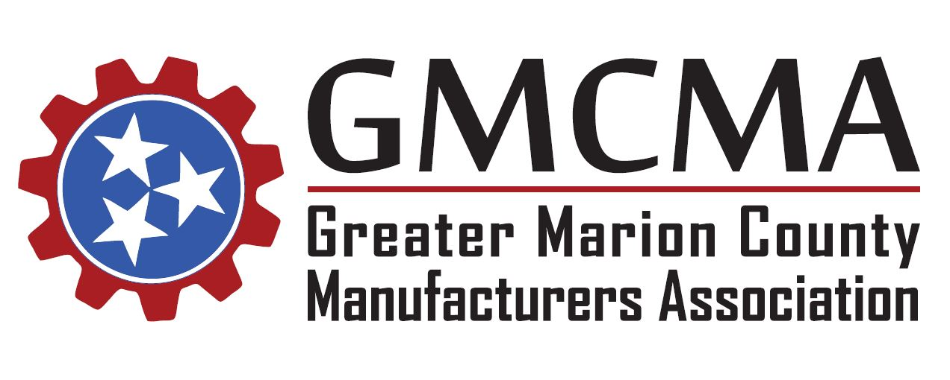

Thursday, August 30, 2018
Meeting Minutes
The Greater Marion County Manufacturers Association met today at 11:30 am CST at Western Sizzlin in Jasper.
Those in attendance included: Taylor McNeill (Primex Plastics), Brian Baker (Primex Plastics), John Schwab (Primex Plastics), Ryan Manning (Colonial Chemical), Doug Wynn (Colonial Chemical), Tracy Middleton (Mann+Hummel), Tim Brown (Mann+Hummel), Alex Gardner (U.S. Stove), Rachael Adams (Valmont), Michael Fox (Valmont), Taylor Belcker (TNECD), Roy Sofield (Chattanooga State), Mike Ricketts (TCAT), Bobby Day (TCAT), Jeff Long (TCAT), Amanda Brooks (Lodge Manufacturing), Amanda Groves (Lodge Manufacturing), Jackie Carter (Lodge Manufacturing), Derek Bartley (C2Q), Kelly Taylor (TN Galvanizing), Randall Tussey (Shaw Industries), Golda Elliot (Marion County Schools), Kay Light (Marion County Schools), Lulu Copeland (Chattanooga State), Julie Bennett (Chattanooga State), Duane Johnson (Jasper Ind. Park), Carri Smith (Valmont), Kyle Summers (American Job Center), and Patrick O’Hagan (American Job Center).
The meeting was called to order and those in attendance were welcomed by Co-Chair Duane Johnson. New members to the association were introduced to the group, and all in attendance introduced themselves and the companies they represent.
Previous meeting minutes from the July meeting were distributed to the group via email and unanimously approved.
Association Announcements:
Patrick O’Hagan announced updates to the association’s website. The webpage has been updated and revamped to include all current members. A new page was also created for all previous meeting agendas and minutes. Moving forward all minutes will be uploaded to the site for group review and approval.
Kyle Summers, representing the American Job Center, introduced himself to the association. Kyle is currently the Adults and Dislocated Workers Case Manager at the Marion County American Job Center. He will be attending the association meetings and assisting with organizational details. He also informed the group of the Job Center’s new location in Jasper at 5510 Hwy. 41, the Marion County Commission Building.
Chattanooga State Community College Presentation:
Dr. Roy Sofield, Interim Dean of Academic Affairs, began the presentation to the association for Chattanooga State. He provided updates on current student enrollment, TN Reconnect information, etc. Dr. Mike Ricketts then provided an update regarding the Tennessee College of Applied Technology Fall Semester. In Marion County, 18 students are currently enrolled in each program – Industrial Maintenance and Welding Technology.
Julie Bennett and Lulu Copeland also presented to the group. Julie provided a background to Chattanooga State’s history and growth in Marion County. Lulu then addressed the industry leaders regarding training programs that can be designed to meet specific business needs. Any members interested in such tailor-made training options were encouraged to contact her for further information.
Training with Industry (TWI):
Derek Bartley, President of C2Q, presented an overview of a TWI course that he offers for industry. He reviewed the modules associated with the training and provided insight into the program. Derek comes from an automotive manufacturing background, and assists companies with turnarounds to provide increased growth. An email will be sent to all members to gauge current and future TWI interest.
Next month’s meeting will feature guest speaker Vincent Phipps, Communication Coach of VIP Communications. His presentation will be entitled “Communication without Confrontation.”
With no other topics on the agenda to be discussed, the meeting was adjourned. The next GMCMA meeting will be held on Thursday, September 27, 2018.

