___________________________________________________
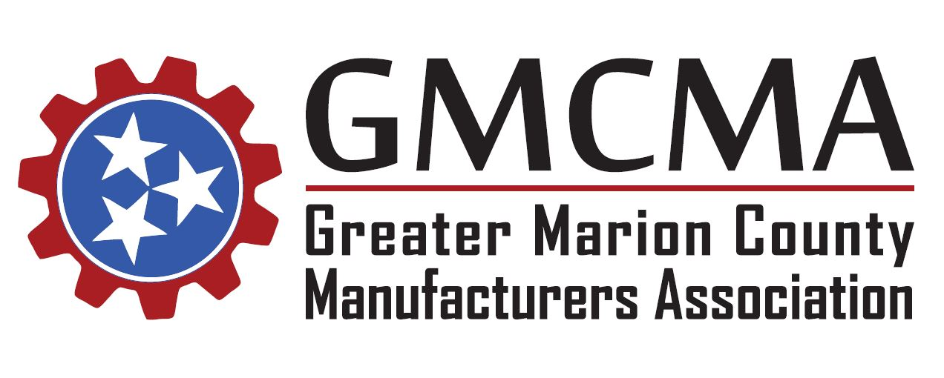

Thursday, June 28, 2018
Meeting Minutes
The Greater Marion County Manufacturers Association met today at 11:30 am CST at Western Sizzlin in Jasper.
Those in attendance included: Doug Fox (Tennessee Tub Factory), Sonny Chiarello (Prologue), Taylor Wilson (Primex Plastics), John Schwab (Primex Plastics), Doug Wynn (Colonial Chemcial), Carmen O’Hagan (Colonial Chemical), Jennifer Brooks (Valmont), Bruce Bacon (Valmont), Rachael Adams (Valmont), Jeff Long (Chattanooga State), Kay Light (Marion Co. Board of Ed.), Golda Elliott (MCBOE), Larry Ziegler (MCBOE), Michael Griffith (TN American Water), Kelly Taylor (TN Galvanizing), Cydnie Tate (Chattanooga State), Lulu Copeland (Chattanooga State), and Patrick O’Hagan (American Job Center).
The meeting was called to order and those in attendance were welcomed by Doug Wynn. New members to the association were introduced to the group, and all in attendance introduced themselves and the companies they represent.
Previous meeting minutes from the May meeting were distributed to the group via email and unanimously approved.
Association Announcements:
As co-chairs Carri Smith and Duane Johnson were unable to attend, Doug Wynn led the meeting and provided the group with an overview of the remaining meeting dates and topics for 2018. The GMCMA will finish out the year with regularly scheduled meetings for July, August, September, and October. Doug revisited the topic and interest in completing a GMCMA service project in October, and the group will continue to discuss and plan for that. The month of November and December will be used as administrative planning months for the upcoming year.
Tennessee Workforce Readiness and NCRC:
Kay Light, Career and Technical Education Director for Marion County Schools, presented as the guest speaker. She distributed information packets to those in attendance and covered three main topics related to Tennessee Workforce Readiness and its impact on local industry. Kay reviewed the ACT WorkKeys assessment, the CPT (Certified Production Technician) certification, and the Work Ethic Diploma.
Following the presentation, Kay was recognized for her years of service and dedication as she is retiring from role with Marion County Schools this month. The association applauded her for her commitment to education and workforce development, especially for her close partnership with local industry during the formation of the GMCMA. Larry Ziegler will pickup where Kay left off and serve as the new Director. He invited the organization members to Central Prep Academy on July 11, 2018 to view a technical education training for teachers, so that industry could see firsthand what they are covering.
Next Meeting:
Next month’s meeting will feature guest speaker Stacy Morrison with the Tennessee Department of Transportation. Stacy will present a TDOT Marion County Update and be on hand to address infrastructure topics for the association.
With no other topics on the agenda to be discussed, the meeting was adjourned. The next GMCMA meeting will be held on Thursday, July 26, 2018.

